

***Department of Data Science & Technology***

***Certificate***

***Master in Computer Applications***

***Trimester IV (2021 – 22)***

***This is to certify that Ms. Saayli Yadav Roll No. 47 of MCA, has satisfactorily completed the practical course “ Big Data Analytics” prescribed by the College for the Partial Fulfillment of the Degree by the Somaiya Vidyavihar University, during the academic year 2021-23.***

***Signature of the Faculty-Incharge Signature of the Programme***

***(Dr. Bharati Wukkadada W) Coordinator***

***(Dr. Bharati Wukkadada W)***

***Date of Examination Signature of the External Examiner/s***

**INDEX**

|  |  |  |  |
| --- | --- | --- | --- |
| **Sr. No** | **Contents** | **Date Of Submission** | **Page Number** |
| 1 | Word count | 08- Aug-2022 | 3 |
| 2 | Write a program to find average word length | 16-Aug-2022 | 8 |
| 3 | Encrypt the email | 23-Aug-2022 | 13 |
| 4 | Create 2 or 3 input files on your own , in which the data is present in different format. Write a program to process the these files using different map class and perform any one aggerate function like sum,  max, min etc. on it. | 29-Aug-2022 | 20 |
| 5 | Find Out the hit count per month | 30-Aug-2022 | 31 |
| 6 | Write a MapReduce program to find profession-wise (choose any 5 professions) of customer count from the "cust" dataset. | 02-Sep-2022 | 40 |
| 7 | Find hit per month using pig | 07-Sep-2022 | 49 |
| 8 | Crime data analysis using pig | 10-Sep-2022 | 53 |

**PRACTICAL – 1**

**Assignment – word Count**

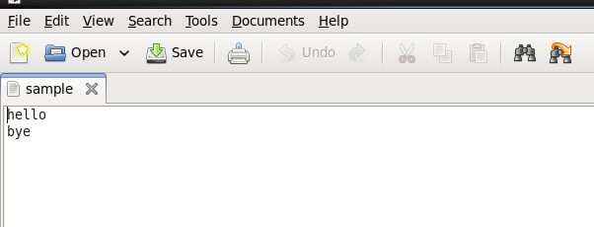

Program

**import** java.io.IOException;

**import** org.apache.hadoop.fs.Path;

**import** org.apache.hadoop.io.IntWritable;

**import** org.apache.hadoop.io.Text;

**import** org.apache.hadoop.mapreduce.lib. input.FileInputFormat;

**import** org.apache.hadoop.mapreduce.lib.output.FileOutputFormat;

**import** org.apache.hadoop.mapreduce.Job;

**import** org.apache.hadoop.io.LongWritable;

**import** org.apache.hadoop.mapreduce.Mapper;

**import** org.apache.hadoop.mapreduce.Reducer;

**public** **class** word_count {

**public** **static** **class** WordMapper **extends**

Mapper<LongWritable, Text, Text, IntWritable>

{

@Override

**public** **void** map(LongWritable key, Text value, Context context) **throws** IOException, InterruptedException

{

String line = value.toString();

**for** (String word : line.split("\\W+"))

{

**if** (word.length() >0)

{

context.write(**new** Text(word), **new** IntWritable(1));

}

}

}

}

**public** **static** **class** SumReducer **extends** Reducer<Text, IntWritable, Text, IntWritable>

{

@Override

**public** **void** reduce(Text key, Iterable<IntWritable> values, Context context) **throws** IOException, InterruptedException

{

**int** wordcount =0;

**for** (IntWritable value:values)

{

wordcount+=value.get();

}

context.write(key, **new** IntWritable(wordcount));

}

}

**public** **static** **void** main(String[] args) **throws** Exception

{

**if**(args.length!=2)

{

System.*out*.printf("Usage: wordcount <input dir> <output dir>\n");

System.*exit*(-1);

}

Job job = **new** Job();

job.setJarByClass(word_count.**class**);

job.setJobName("Word Count");

FileInputFormat.*setInputPaths*(job, **new** Path(args[0]));

FileOutputFormat.*setOutputPath*(job, **new** Path(args[1]));

job.setMapperClass(WordMapper.**class**);

job.setReducerClass(SumReducer.**class**);

job.setOutputKeyClass(Text.**class**);

job.setOutputValueClass(IntWritable.**class**);

**boolean** success = job.waitForCompletion(**true**);

System.*exit*(success ? 0 : 1);

}

}

Create jar

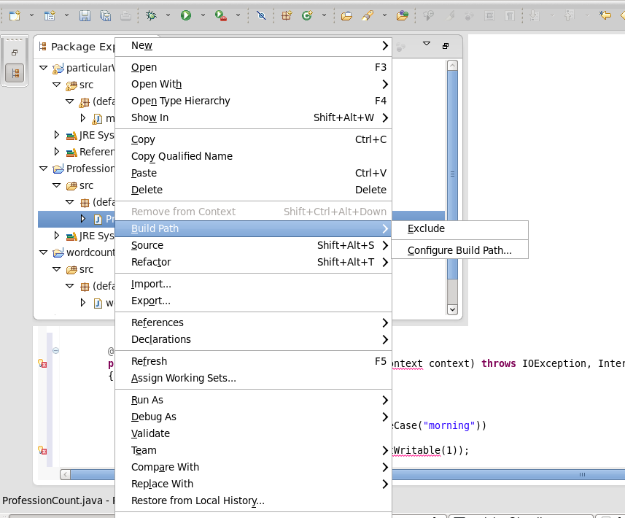

In terminal

**PRACTICAL – 2**

**Assignment - Specific Word Count**

Create Text file

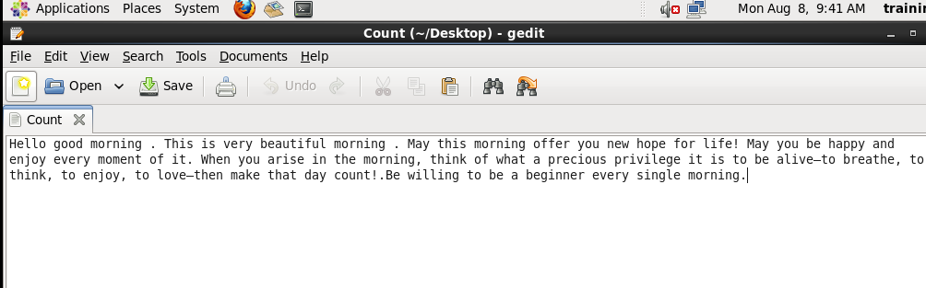

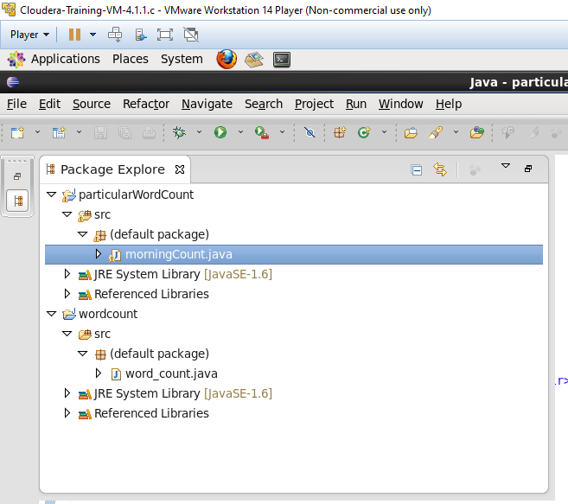

Program

import java.io.IOException;

import org.apache.hadoop.fs.Path;

import org.apache.hadoop.io.IntWritable;

import org.apache.hadoop.io.Text;

import org.apache.hadoop.mapreduce.Reducer.Context;

import org.apache.hadoop.mapreduce.lib. input.FileInputFormat;

import org.apache.hadoop.mapreduce.lib.output.FileOutputFormat;

import org.apache.hadoop.mapreduce.Job;

import org.apache.hadoop.io.LongWritable;

import org.apache.hadoop.mapreduce.Mapper;

import org.apache.hadoop.mapreduce.Reducer;

//import morningCount.SumReducer;

//import morningCount.WordMapper;

public class morningCount {

public static class WordMapper extends

Mapper<LongWritable, Text, Text, IntWritable>

{

@Override

public void map(LongWritable key, Text value, Context context) throws IOException, InterruptedException

{

String line = value.toString();

for (String word : line.split("\\W+"))

{

if (word.length() >0 && word.equalsIgnoreCase("morning"))

{

context.write(new Text(word), new IntWritable(1));

}

}

}

}

public static class SumReducer extends Reducer<Text, IntWritable, Text, IntWritable>

{

@Override

public void reduce(Text key, Iterable<IntWritable> values, Context context) throws IOException, InterruptedException

{

int wordcount =0;

for (IntWritable value:values)

{

wordcount+=value.get();

}

context.write(key, new IntWritable(wordcount));

}

}

public static void main(String[] args) throws Exception

{

if(args.length!=2)

{

System.out.printf("Usage: wordcount <input dir> <output dir>\n");

System.exit(-1);

}

Job job = new Job();

job.setJarByClass(morningCount.class);

job.setJobName("Word Count");

FileInputFormat.setInputPaths(job, new Path(args[0]));

FileOutputFormat.setOutputPath(job, new Path(args[1]));

job.setMapperClass(WordMapper.class);

job.setReducerClass(SumReducer.class);

job.setOutputKeyClass(Text.class);

job.setOutputValueClass(IntWritable.class);

boolean success = job.waitForCompletion(true);

System.exit(success ? 0 : 1);

}

}

Create jar

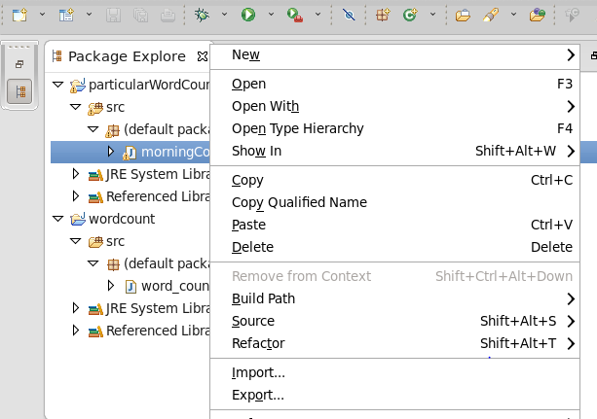

Right click on file -> export

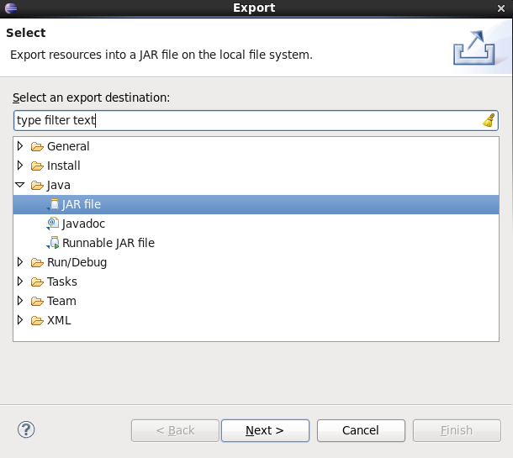

Java -> jar file

Next ->

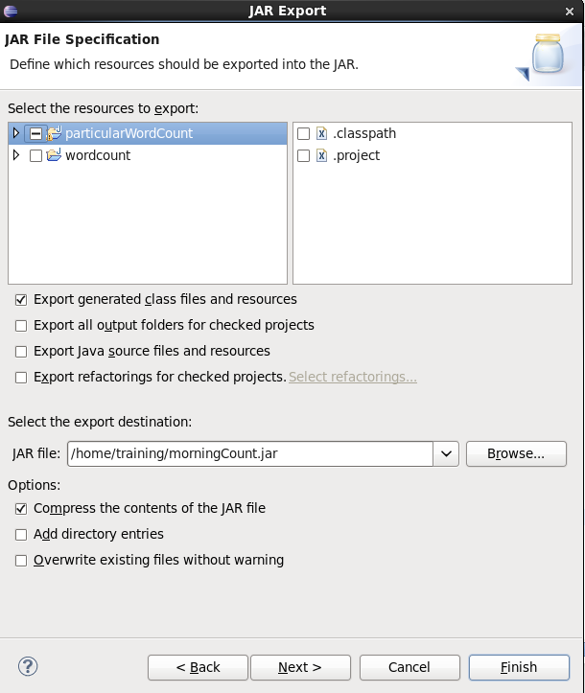

Give jar name

Next

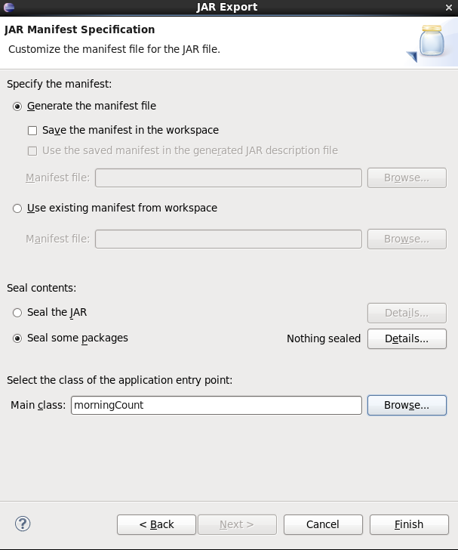

Select main class

Finish

Then in terminal

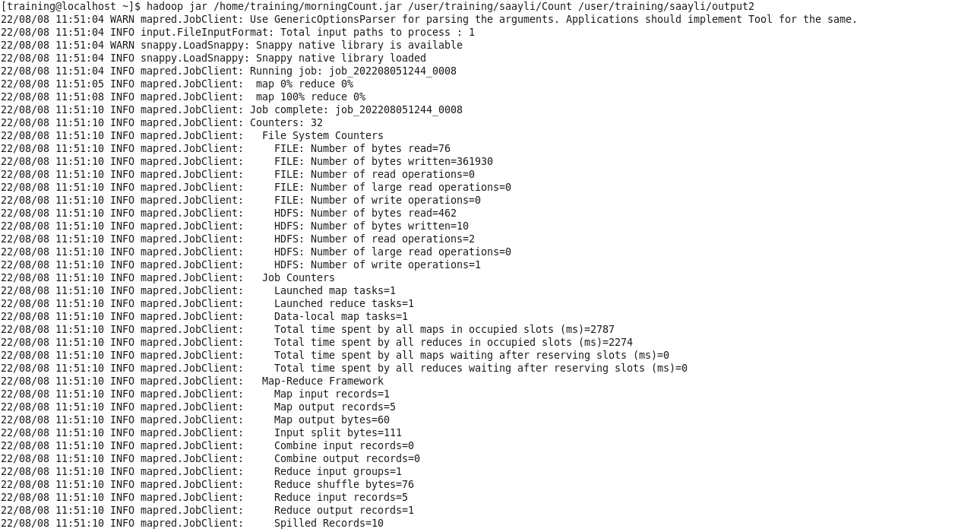

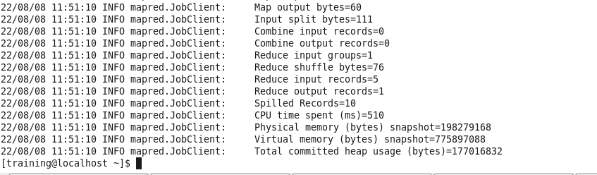

Go to hdfs

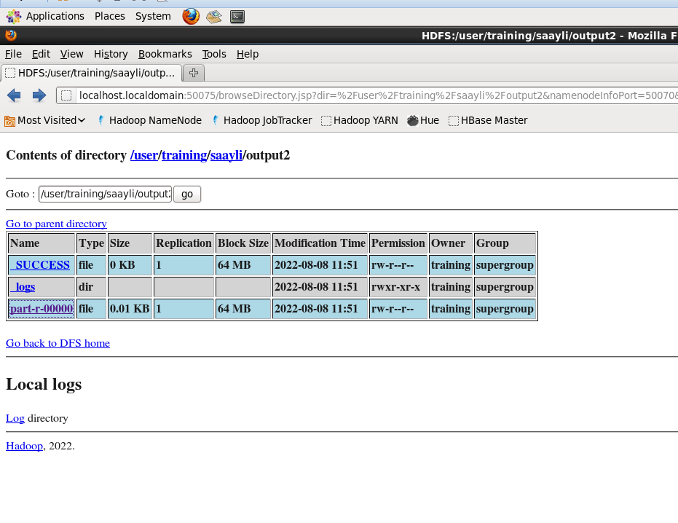

Click on part - r- 0000

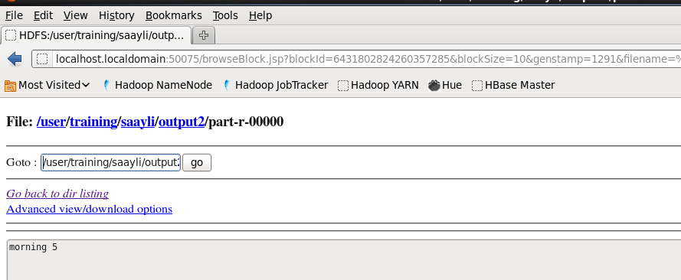

**PRACTICAL – 3**

**Assignment : Write a program to find average word length**

**import** java.io.IOException;

**import** java.util.*;

**import** org.apache.hadoop.fs.Path;

**import** org.apache.hadoop.io.DoubleWritable; **import** org.apache.hadoop.io.IntWritable; **import** org.apache.hadoop.io.Text;

**import** org.apache.hadoop.mapreduce.Reducer.Context;

**import** org.apache.hadoop.mapreduce.lib.input.FileInputFormat; **import** org.apache.hadoop.mapreduce.lib.output.FileOutputFormat; **import** org.apache.hadoop.mapreduce.Job;

**import** org.apache.hadoop.io.LongWritable; **import** org.apache.hadoop.mapreduce.Mapper; **import** org.apache.hadoop.mapreduce.Reducer;

**public class** Average {

**public static class** WordMapper **extends** Mapper <LongWritable, Text, Text, IntWritable>

{

@Override

**public void** map(LongWritable key,Text value, Context context)

**throws** IOException, InterruptedException{ Text firstLetter = **new** Text();

IntWritable wordLength = **new** IntWritable();

**char**[] a1 = **null**;

String line = value.toString().toLowerCase();

**for**(String word:line.split(" ")){

**if** (word.length() > 0) { firstLetter.set(String.*valueOf*(word.charAt(0)));

wordLength.set(word.length()); context.write(firstLetter, wordLength);

}

}

}

}

**public static class** SumReducer **extends** Reducer<Text,IntWritable,Text,IntWritable>{

**public void** reduce(Text key,Iterable<IntWritable>values,Context context)

**throws** IOException,InterruptedException{

**int** sum =0;

**int** count =0;

**int** Average =0;

**for**(IntWritable val:values) { sum += val.get();

count = count+1;

}

Average = sum/count;

context.write(key,**new** IntWritable(Average));

}

}

**public static void** main(String[] args) **throws** Exception{

**if**(args.length != 2){ System.*out*.printf(

"Usage: WordCount <input dir> <output dir> \n");

System.*exit*(-1);

}

Job job = **new** Job();

job.setJarByClass(Average.**class**); job.setJobName("Word Count");

FileInputFormat.*setInputPaths*(job, **new** Path(args[0])); FileOutputFormat.*setOutputPath*(job, **new** Path(args[1]));

job.setMapperClass(WordMapper.**class**); job.setReducerClass(SumReducer.**class**);

job.setOutputKeyClass(Text.**class**); job.setOutputValueClass(IntWritable.**class**);

**boolean** success = job.waitForCompletion(**true**); System.*exit*(success ? 0 :1);

}

}

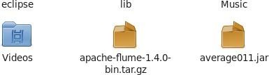

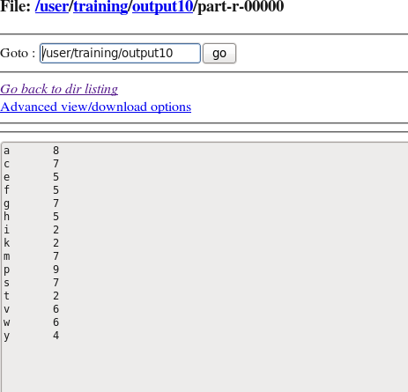

**PRACTICAL – 4**

**Assignment : Encrypt the emails using only mapper**

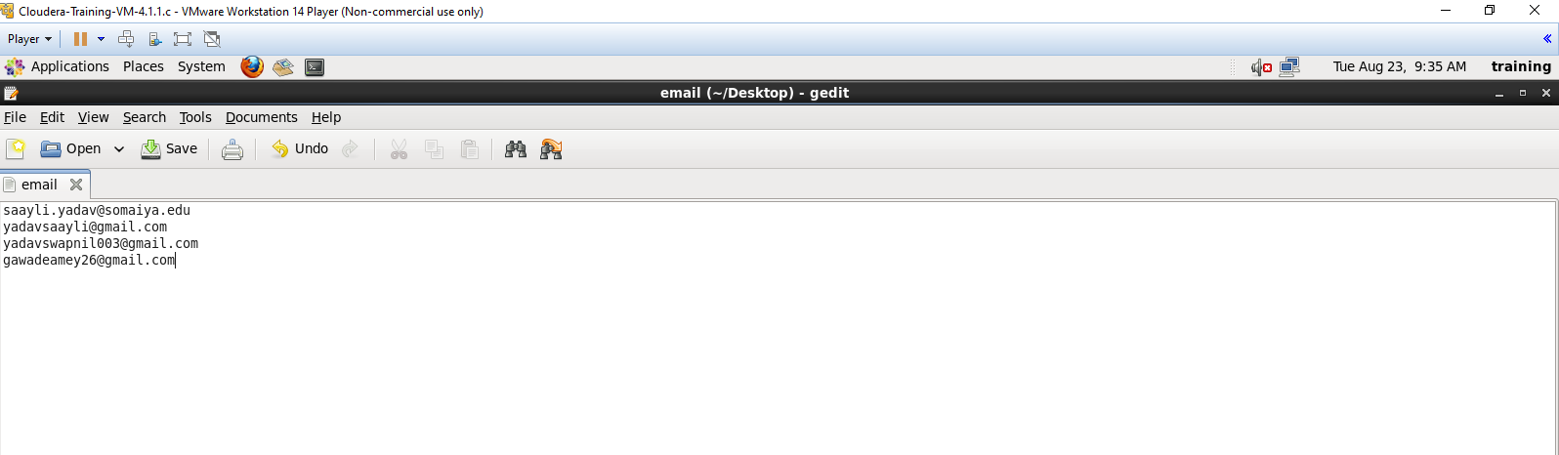

In terminal



Copy the jar files from classroom to vmware desktop

Create the java file

Right click on file -> JRE -> Build Path -> configure path -> add external jar files -> add the jar files

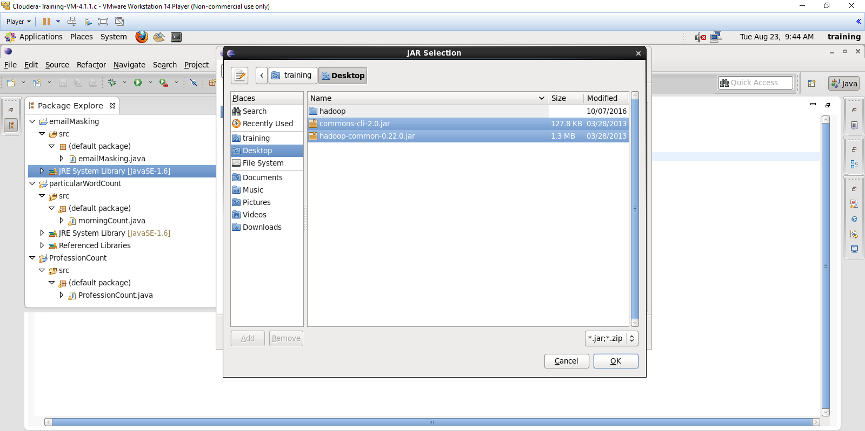

Code:

**import** java.io.IOException;

**import** org.apache.hadoop.conf.Configuration;

**import** org.apache.hadoop.fs.Path;

**import** org.apache.hadoop.io.IntWritable;

**import** org.apache.hadoop.io.Text;

**import** org.apache.hadoop.mapreduce.Mapper.Context;

**import** org.apache.hadoop.mapreduce.lib.input.FileInputFormat;

**import** org.apache.hadoop.mapreduce.lib.output.FileOutputFormat;

**import** org.apache.hadoop.mapreduce.Job;

**import** org.apache.hadoop.io.LongWritable;

**import** org.apache.hadoop.mapreduce.Mapper;

**import** org.apache.hadoop.mapreduce.Reducer;

**import** org.apache.hadoop.util.GenericOptionsParser;

**class** emailMasking {

**public** **static** **class** MapForEmail **extends** Mapper<LongWritable ,Text,Text ,Text>

{

**public** **void** map(LongWritable Key,Text value,Context con) **throws** IOException,

InterruptedException

{

String text = value.toString();

String result="";

**for** (**int** i=0; i<text.length(); i++)

{

**if** (Character.*isUpperCase*(text.charAt(i)))

{

**char** ch = (**char**)(((**int**)text.charAt(i) +

3 - 65) % 26 + 65);

result= result+ch;

}

**else**

{

**char** ch = (**char**)(((**int**)text.charAt(i) +

3 - 97) % 26 + 97);

result= result+ch;

}

}

String line1 = result + ".com";

String value1 = "";

Text outputKey = **new** Text(line1);

con.write(outputKey,**new** Text(value1));

}

}

**public** **static** **void** main(String[] args)**throws** Exception

{

Configuration c = **new** Configuration();

String[] files = **new** GenericOptionsParser(c,args).getRemainingArgs();

Path input = **new** Path(files[0]);

Path output = **new** Path(files[1]);

Job j = **new** Job(c,"FormatEmpFile");

j.setJarByClass(emailMasking.**class**);

j.setMapperClass(MapForEmail.**class**);

j.setNumReduceTasks(0);

j.setMapOutputKeyClass(Text.**class**);

j.setMapOutputValueClass(Text.**class**);

FileInputFormat.*addInputPath*(j,input);

FileOutputFormat.*setOutputPath*(j,output);

System.*exit*(j.waitForCompletion(**true**)?0:1);

}

}

Logic of code: ceasar cipher

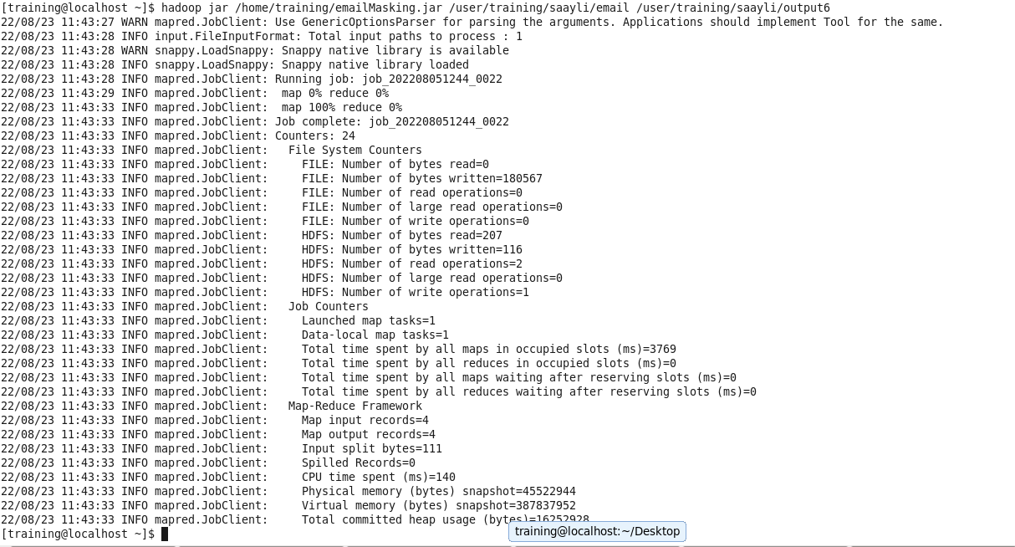

Output:

**PRACTICAL – 5**

**Assignment :** **Create 2 or 3 input files on your own , in which the data is present in different format. Write a program to process the these files using different map class and perform any one aggerate function like sum, max, min etc. on it.**

Input file

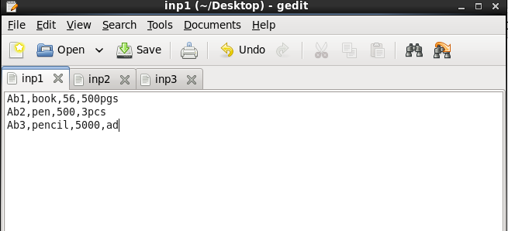

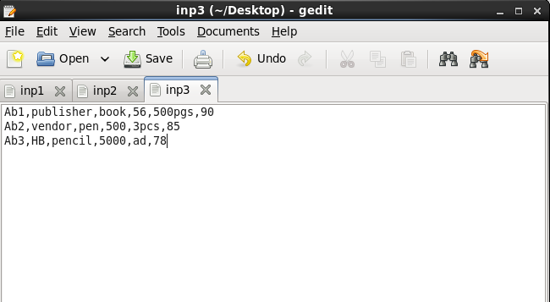

Copy to the folder



To find minimum

Code:

**import** java.io.IOException;

**import** org.apache.hadoop.conf.Configuration;

**import** org.apache.hadoop.fs.Path;

**import** org.apache.hadoop.io.IntWritable;

**import** org.apache.hadoop.io.Text;

**import** org.apache.hadoop.mapreduce.lib.input.FileInputFormat;

**import** org.apache.hadoop.mapreduce.lib.output.FileOutputFormat;

**import** org.apache.hadoop.mapreduce.Job;

**import** org.apache.hadoop.io.LongWritable;

**import** org.apache.hadoop.mapreduce.Mapper;

**import** org.apache.hadoop.mapreduce.Reducer;

**import** org.apache.hadoop.util.GenericOptionsParser;

**import** org.apache.hadoop.mapreduce.lib.input.MultipleInputs;

**import** org.apache.hadoop.mapreduce.lib.input.TextInputFormat;

**import** java.util.Arrays;

**public** **class** maxMultipleInput {

**public** **static** **class** Map1 **extends** Mapper<LongWritable, Text, Text, IntWritable>

{

**public** **void** map(LongWritable key, Text value, Context con) **throws** IOException, InterruptedException

{

String line = value.toString();

String[] line1 = line.split(",");

String name = line1[0];

Text outputKey = **new** Text(name);

**int** price = Integer.*parseInt*(line1[2]);

IntWritable outputValue = **new** IntWritable(price);

con.write(outputKey, outputValue);

}

}

**public** **static** **class** Map2 **extends** Mapper<LongWritable, Text, Text, IntWritable>

{

**public** **void** map(LongWritable key, Text value, Context con) **throws** IOException, InterruptedException

{

String line = value.toString();

String[] line1 = line.split(",");

String name = line1[0];

Text outputKey = **new** Text(name);

**int** price = Integer.*parseInt*(line1[3]);

IntWritable outputValue = **new** IntWritable(price);

con.write(outputKey, outputValue);

}

}

**public** **static** **class** Map3 **extends** Mapper<LongWritable, Text, Text, IntWritable>

{

**public** **void** map(LongWritable key, Text value, Context con) **throws** IOException, InterruptedException

{

String line = value.toString();

String[] line1 = line.split(",");

String name = line1[0];

Text outputKey = **new** Text(name);

**int** price = Integer.*parseInt*(line1[5]);

IntWritable outputValue = **new** IntWritable(price);

con.write(outputKey, outputValue);

}

}

**public** **static** **class** Red **extends** Reducer<Text, IntWritable, Text, IntWritable>

{

**public** **void** reduce(Text name, Iterable<IntWritable> price, Context con) **throws** IOException, InterruptedException

{

// float sum = 0;

// for(IntWritable value : price)

// {

// sum += value.get();

// }

// con.write(name, new IntWritable(sum));

// int max = Integer.MIN_VALUE;

**int** min = 9999;

**for**(IntWritable value: price)

{

min = Math.*min*(min, value.get());

}

con.write(name, **new** IntWritable(min));

}

**public** **static** **void** main(String[] args) **throws** Exception

{

Configuration c = **new** Configuration();

GenericOptionsParser parser = **new** GenericOptionsParser(c, args);

String[] files = parser.getRemainingArgs();

Path p1 = **new** Path(files[0]);

Path p2 = **new** Path(files[1]);

Path p3 = **new** Path(files[2]);

Path p4 = **new** Path(files[3]);

Job j = **new** Job(c, "multiple");

j.setJarByClass(maxMultipleInput.**class**);

j.setMapperClass(Map1.**class**);

j.setMapperClass(Map2.**class**);

j.setMapperClass(Map3.**class**);

j.setReducerClass(Red.**class**);

j.setOutputKeyClass(Text.**class**);

j.setOutputValueClass(IntWritable.**class**);

MultipleInputs.*addInputPath*(j, p1, TextInputFormat.**class**, Map1.**class**);

MultipleInputs.*addInputPath*(j, p2, TextInputFormat.**class**, Map2.**class**);

MultipleInputs.*addInputPath*(j, p3, TextInputFormat.**class**, Map3.**class**);

FileOutputFormat.*setOutputPath*(j, p4);

System.*exit*(j.waitForCompletion(**true**) ? 0:1);

}

}

}

Ouput :

To find Maximum

**import** java.io.IOException;

**import** org.apache.hadoop.conf.Configuration;

**import** org.apache.hadoop.fs.Path;

**import** org.apache.hadoop.io.IntWritable;

**import** org.apache.hadoop.io.Text;

**import** org.apache.hadoop.mapreduce.lib.input.FileInputFormat;

**import** org.apache.hadoop.mapreduce.lib.output.FileOutputFormat;

**import** org.apache.hadoop.mapreduce.Job;

**import** org.apache.hadoop.io.LongWritable;

**import** org.apache.hadoop.mapreduce.Mapper;

**import** org.apache.hadoop.mapreduce.Reducer;

**import** org.apache.hadoop.util.GenericOptionsParser;

**import** org.apache.hadoop.mapreduce.lib.input.MultipleInputs;

**import** org.apache.hadoop.mapreduce.lib.input.TextInputFormat;

**import** java.util.Arrays;

**public** **class** maxMultipleInput {

**public** **static** **class** Map1 **extends** Mapper<LongWritable, Text, Text, IntWritable>

{

**public** **void** map(LongWritable key, Text value, Context con) **throws** IOException, InterruptedException

{

String line = value.toString();

String[] line1 = line.split(",");

String name = line1[0];

Text outputKey = **new** Text(name);

**int** price = Integer.*parseInt*(line1[2]);

IntWritable outputValue = **new** IntWritable(price);

con.write(outputKey, outputValue);

}

}

**public** **static** **class** Map2 **extends** Mapper<LongWritable, Text, Text, IntWritable>

{

**public** **void** map(LongWritable key, Text value, Context con) **throws** IOException, InterruptedException

{

String line = value.toString();

String[] line1 = line.split(",");

String name = line1[0];

Text outputKey = **new** Text(name);

**int** price = Integer.*parseInt*(line1[3]);

IntWritable outputValue = **new** IntWritable(price);

con.write(outputKey, outputValue);

}

}

**public** **static** **class** Map3 **extends** Mapper<LongWritable, Text, Text, IntWritable>

{

**public** **void** map(LongWritable key, Text value, Context con) **throws** IOException, InterruptedException

{

String line = value.toString();

String[] line1 = line.split(",");

String name = line1[0];

Text outputKey = **new** Text(name);

**int** price = Integer.*parseInt*(line1[5]);

IntWritable outputValue = **new** IntWritable(price);

con.write(outputKey, outputValue);

}

}

**public** **static** **class** Red **extends** Reducer<Text, IntWritable, Text, IntWritable>

{

**public** **void** reduce(Text name, Iterable<IntWritable> price, Context con) **throws** IOException, InterruptedException

{

// float sum = 0;

// for(IntWritable value : price)

// {

// sum += value.get();

// }

// con.write(name, new IntWritable(sum));

// int max = Integer.MIN_VALUE;

**int** min = 0;

**for**(IntWritable value: price)

{

min = Math.*max*(min, value.get());

}

con.write(name, **new** IntWritable(min));

}

**public** **static** **void** main(String[] args) **throws** Exception

{

Configuration c = **new** Configuration();

GenericOptionsParser parser = **new** GenericOptionsParser(c, args);

String[] files = parser.getRemainingArgs();

Path p1 = **new** Path(files[0]);

Path p2 = **new** Path(files[1]);

Path p3 = **new** Path(files[2]);

Path p4 = **new** Path(files[3]);

Job j = **new** Job(c, "multiple");

j.setJarByClass(maxMultipleInput.**class**);

j.setMapperClass(Map1.**class**);

j.setMapperClass(Map2.**class**);

j.setMapperClass(Map3.**class**);

j.setReducerClass(Red.**class**);

j.setOutputKeyClass(Text.**class**);

j.setOutputValueClass(IntWritable.**class**);

MultipleInputs.*addInputPath*(j, p1, TextInputFormat.**class**, Map1.**class**);

MultipleInputs.*addInputPath*(j, p2, TextInputFormat.**class**, Map2.**class**);

MultipleInputs.*addInputPath*(j, p3, TextInputFormat.**class**, Map3.**class**);

FileOutputFormat.*setOutputPath*(j, p4);

System.*exit*(j.waitForCompletion(**true**) ? 0:1);

}

}

}

Output :

**PRACTICAL – 6**

**Assignment : Find Out the hit count per month**

Input File

Code :

**import** java.io.*;

**import** org.apache.hadoop.io.*;

**import** org.apache.hadoop.mapreduce.*;

**import** org.apache.hadoop.conf.*;

**import** org.apache.hadoop.fs.*;

**import** org.apache.hadoop.mapreduce.lib. input.*;

**import** org.apache.hadoop.mapreduce.lib.output.*;

**import** org.apache.hadoop.util.*;

**public** **class** countHitInMonth **extends** Configured **implements** Tool{

//map class

**public** **static** **class** Map **extends** Mapper<LongWritable, Text, Text, IntWritable> {

@Override **public** **void** map (LongWritable key, Text value, Context context)

**throws** IOException, InterruptedException {

String line = value.toString();

String[] word =line.split("/") ;

String code=word[1];

context.write(**new** Text (code), **new** IntWritable (1));

}

}

//Reducer class

**public** **static** **class** SumReducer **extends** Reducer<Text, IntWritable, Text, IntWritable> {

@Override **public** **void** reduce (Text key, Iterable<IntWritable> values, Context context)

**throws** IOException, InterruptedException {

**int** wordCount = 0;

**for** (IntWritable value : values) {

wordCount += value.get();

}

context.write(key, **new** IntWritable (wordCount));

}

}

//Partitioner class

**public** **static** **class** CaderPartitioner **extends** Partitioner<Text,IntWritable>{

**public** **int** getPartition ( Text key , IntWritable value , **int** numReduceTasks )

{

**if** ( numReduceTasks == 0 )

{

**return** 0 ;

}

**if** ( key.toString().equals("Jan"))

{

**return** 1 % numReduceTasks ;

}

**else** **if** (key.toString().equals("Feb"))

{

**return** 2% numReduceTasks;

}

**else** **if** ( key.toString().equals("Mar") )

{

**return** 3% numReduceTasks;

}

**else** **if** ( key.toString().equals("Apr") )

{

**return** 4% numReduceTasks;

}

**else** **if** ( key.toString().equals("May") )

{

**return** 5% numReduceTasks;

}

**else** **if** ( key.toString().equals("Jun") )

{

**return** 6% numReduceTasks;

}

**else** **if** ( key.toString().equals("Jul") )

{

**return** 7% numReduceTasks;

}

**else** **if** ( key.toString().equals("Aug") )

{

**return** 8% numReduceTasks;

}

**else** **if** ( key.toString().equals("Sep") )

{

**return** 9% numReduceTasks;

}

**else** **if** ( key.toString().equals("Oct") )

{

**return** 10% numReduceTasks;

}

**else** **if** ( key.toString().equals("Nov") )

{

**return** 11% numReduceTasks;

}

**else** **if** ( key.toString().equals("Dec") )

{

**return** 12% numReduceTasks;

}

**else**{

**return** 0;

}

}

}

**public** **static** **void** main(String[] args) **throws** Exception{

// **TODO** Auto-generated method stub

**int** res=ToolRunner.*run*(**new** Configuration(),**new** countHitInMonth(), args);

System.*exit*(0);

}

@Override

**public** **int** run(String[] arg) **throws** Exception {

// **TODO** Auto-generated method stub

Configuration conf = getConf() ;

Job job = **new** Job (conf ,"countHitInMonth" ) ;

job.setJarByClass(countHitInMonth.**class** ) ;

FileInputFormat.*setInputPaths* (job ,**new** Path ( arg [ 0 ]));

FileOutputFormat.*setOutputPath* (job ,**new** Path ( arg [ 1 ]));

job.setMapperClass(Map.**class** ) ;

job.setMapOutputKeyClass ( Text.**class** ) ;

job.setMapOutputValueClass (IntWritable.**class** ) ;

// set partitioner statement

job.setPartitionerClass (CaderPartitioner.**class** ) ;

job.setReducerClass(SumReducer.**class**);

job.setNumReduceTasks(13) ;

job.setInputFormatClass (TextInputFormat.**class** ) ;

job.setOutputFormatClass(TextOutputFormat.**class** ) ;

job.setOutputKeyClass ( Text.**class** ) ;

job.setOutputValueClass ( Text.**class** ) ;

System.*exit*(job.waitForCompletion ( **true**) ? 0 : 1);

**return** 0 ;

}

}

Output :

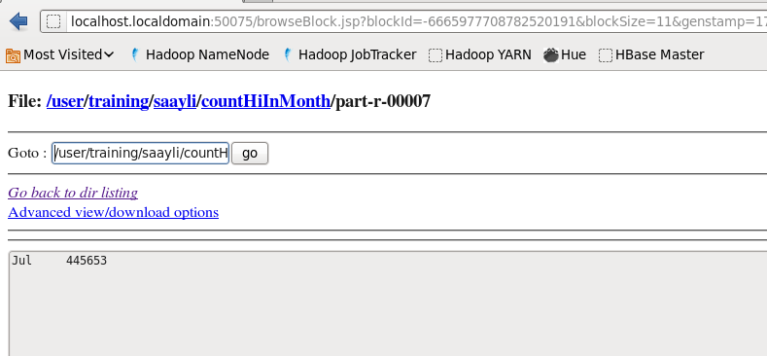

**PRACTICAL – 7**

**Assignment : Write a MapReduce program to find profession-wise (choose any 5 professions) of customer count from the "cust" dataset.**

Copy the custs data to hdfs



Input file

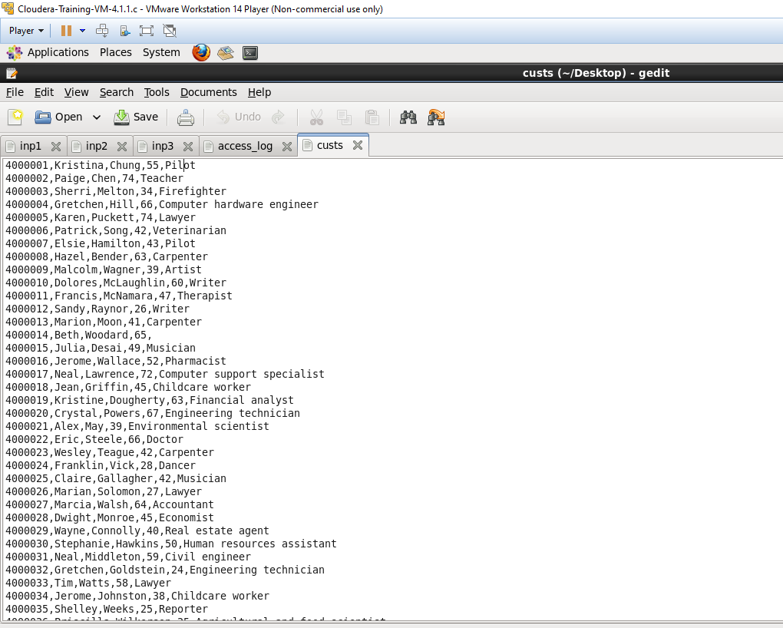

Code :

**import** java.io.*;

**import** org.apache.hadoop.io.*;

**import** org.apache.hadoop.mapreduce.*;

**import** org.apache.hadoop.conf.*;

**import** org.apache.hadoop.fs.*;

**import** org.apache.hadoop.mapreduce.lib. input.*;

**import** org.apache.hadoop.mapreduce.lib.output.*;

**import** org.apache.hadoop.util.*;

**public** **class** customerProfessionCount **extends** Configured **implements** Tool{

//map class

**public** **static** **class** Map **extends** Mapper<LongWritable, Text, Text, IntWritable> {

@Override **public** **void** map (LongWritable key, Text value, Context context)

**throws** IOException, InterruptedException {

String line = value.toString();

String[] word =line.split(",") ;

String code=word[word.length-1];

context.write(**new** Text (code), **new** IntWritable (1));

}

}

//Reducer class

**public** **static** **class** SumReducer **extends** Reducer<Text, IntWritable, Text, IntWritable> {

@Override **public** **void** reduce (Text key, Iterable<IntWritable> values, Context context)

**throws** IOException, InterruptedException {

**int** wordCount = 0;

**for** (IntWritable value : values) {

wordCount += value.get();

}

context.write(key, **new** IntWritable (wordCount));

}

}

//Partitioner class

**public** **static** **class** CaderPartitioner **extends** Partitioner<Text,IntWritable>{

**public** **int** getPartition ( Text key , IntWritable value , **int** numReduceTasks )

{

**if** ( numReduceTasks == 0 )

{

**return** 0 ;

}

**if** ( key.toString().equals("Pilot"))

{

**return** 1 % numReduceTasks ;

}

**else** **if** (key.toString().equals("Teacher"))

{

**return** 2% numReduceTasks;

}

**else** **if** ( key.toString().equals("Lawyer") )

{

**return** 3% numReduceTasks;

}

**else** **if** ( key.toString().equals("Artist") )

{

**return** 4% numReduceTasks;

}

**else** **if** ( key.toString().equals("Therapist") )

{

**return** 5% numReduceTasks;

}

**else**{

**return** 0;

}

}

}

**public** **static** **void** main(String[] args) **throws** Exception{

// **TODO** Auto-generated method stub

**int** res=ToolRunner.*run*(**new** Configuration(),**new** customerProfessionCount(), args);

System.*exit*(0);

}

@Override

**public** **int** run(String[] arg) **throws** Exception {

// **TODO** Auto-generated method stub

Configuration conf = getConf() ;

Job job = **new** Job (conf ,"customerProfessionCount" ) ;

job.setJarByClass(customerProfessionCount.**class** ) ;

FileInputFormat.*setInputPaths* (job ,**new** Path ( arg [ 0 ]));

FileOutputFormat.*setOutputPath* (job ,**new** Path ( arg [ 1 ]));

job.setMapperClass(Map.**class** ) ;

job.setMapOutputKeyClass ( Text.**class** ) ;

job.setMapOutputValueClass (IntWritable.**class** ) ;

// set partitioner statement

job.setPartitionerClass (CaderPartitioner.**class** ) ;

job.setReducerClass(SumReducer.**class**);

job.setNumReduceTasks(6) ;

job.setInputFormatClass (TextInputFormat.**class** ) ;

job.setOutputFormatClass(TextOutputFormat.**class** ) ;

job.setOutputKeyClass ( Text.**class** ) ;

job.setOutputValueClass ( Text.**class** ) ;

System.*exit*(job.waitForCompletion ( **true**) ? 0 : 1);

**return** 0 ;

}

}

Output :

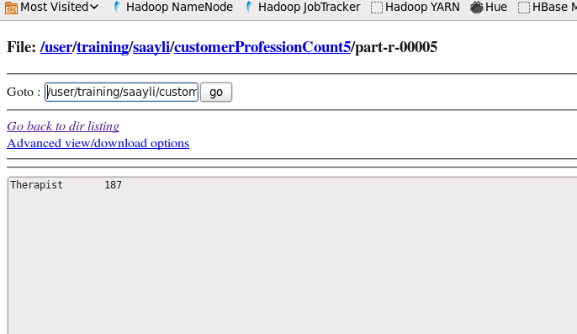

**PRACTICAL – 8**

**Assignment : Find Out the hit count per month using pig**

Input file :

Pig file

pig -f /home/training/Desktop/month.pig

Q . Count age wise from custs

Pig File :

**PRACTICAL – 9**

**Assignment : Solve crime dataset using pig. Solve any four questions**

1. To find the total number of crimes which occurred in all the states in the year 2006

year06 = load '/user/training/saayli/crimeyear.csv' using PigStorage(',') as

(state,crime,y_2001,y_2002,y_2003,y_2004,y_2005,y_2006,y_2007,y_2008,y_2009,y_2010); 

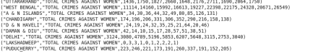

47 - Saayli Yadav

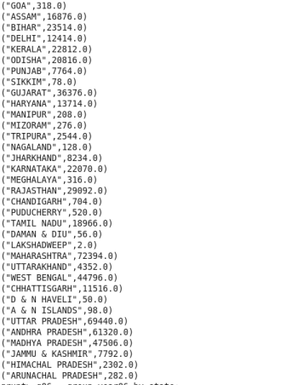47 - Saayli Yadav

2. Calculate the number of females (age between 18-30 years) who were victims in different crimes in different states.

FOREACH crime2006 generate group, SUM( crimeage.$5 );

crimeage = LOAD '/user/training/input/crimeage' using PigStorage(',') AS (STATE:chararray,crimehead:chararray,mb18yr:chararray,fb18yr:int,mb18_30yr:int,fb18_30yr:int ,mb30_45yr:int,fb30_45yr:int,mb45_60yr:int,fb45_60yr:int,mb60_abyr:int,fb60_abyr:int,totalmale :int,totalfemale:int,grandtotal:int);

crimef1830 = GROUP crimeage by (STATE,crimehead);

cf1830 = FOREACH crimef1830 generate group, SUM( crimeage.$5 );

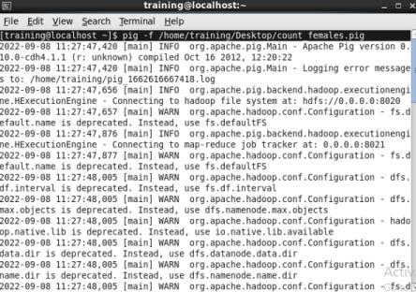Output:

47 - Saayli Yadav

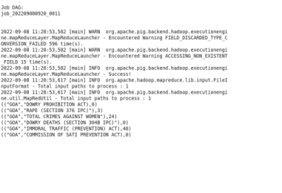47 - Saayli Yadav

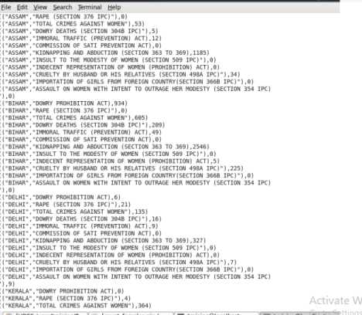47 - Saayli Yadav

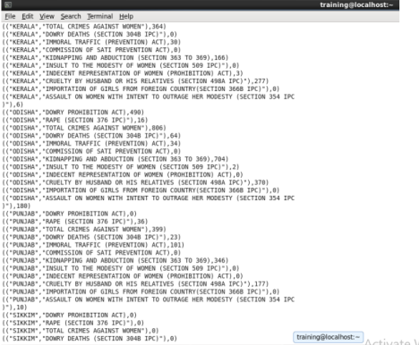47 - Saayli Yadav

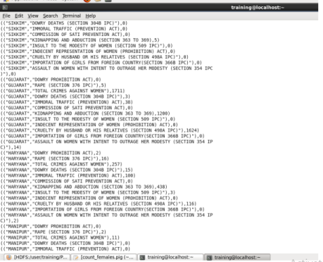47 - Saayli Yadav

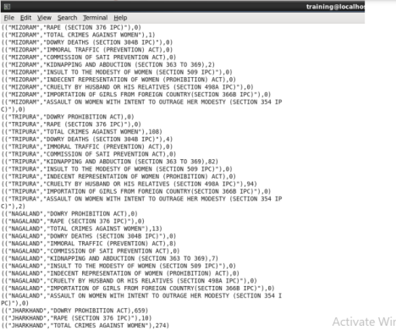47 - Saayli Yadav

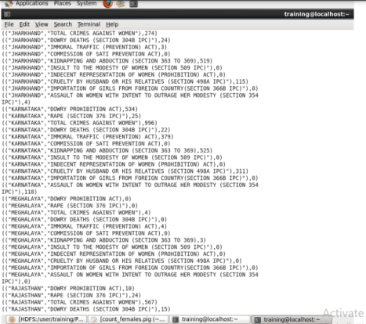47 - Saayli Yadav

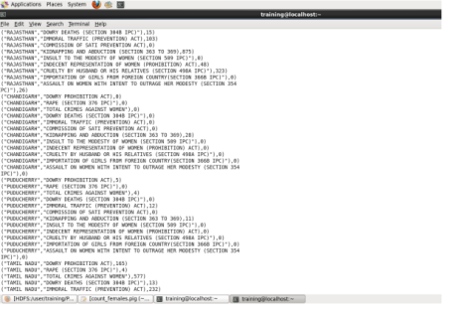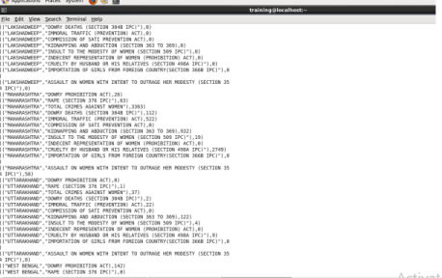47 - Saayli Yadav

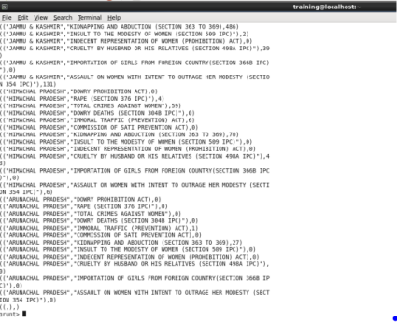4. Find crime wise which state is having highest count



Output :

47 - Saayli Yadav